For this assignment, you will solve problems based on what you have learned in Chapters: Event Handling.

Instructions

• Review the chapters from the book and class notes.
• There are 2 questions in this assignment.
• Assignment submitted after due date will not be evaluated.

Due Date and Time: November 04, in class.

Submitting this Assignment

You do not have to submit this assignment. When you have completed solving all questions, show them to the Instructor.

Grading Criteria

There are no marks to this assignment. Questions:
- Write a program that draws line segments using the arrow keys. The line starts from the center of the pane and draws toward east, north, west, or south when the right-arrow key, up-arrow key, left-arrow key, or down-arrow key is pressed, as shown in figure.
(Hint: Use getKeyCode() method)

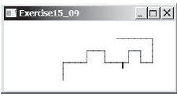

- Write a program that draws a fixed circle centered at (100, 60) with radius 50.Whenever the mouse is moved, display a message indicating whether the mouse point is inside the circle at the mouse point or Check mouse point location outside of it, as shown in Figure.
(Hint: Use getX(), getY() methods to get the X,Y coordinates)

